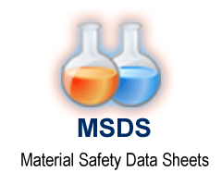

**10**

All fragrances designed and produced, accompanied by Material Safety Data Sheet (***MSDS***), with detailed information such as physical and chemical properties, health, safety, fire, and environmental hazards of product.

The fragrances are produced in compliance with EU regulations, allergen levels are lower than the internationally allowed limits and is accompanied by a Certificate of Conformity (***COC***).

**C.O.C.**

φαρμάκων for medicines

οργανισμός organization

Εθνικός National organization

The manufacturing processes and facilities in which take place the production of E²Aroma’s fragrances, meet the relevant international standards, is conformant with all the requirements and is certified by *National Organization for Medicines* of Greece.

**Certificate Of Conformity**

The selection of suppliers is carried out with extremely strict criteria and are selected with reference to the following certifications.

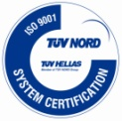

***Franchise Association member***

***International Fragrance***

***TUV Cert en ISO 9001***

***ISSA member***



**11**

***Association Certificated***